BASIC PRINCIPAL OF SPV CONVERSION
2.1) PHOTOVOLTAIC EFFECT:
- Photovoltaic effect is a process in which two dissimilar materials in close contact produce an electrical charge when struck by light or any other radiant energy.
- When light strikes crystals such as silicon or germanium (p-n junction) in which electrons are usually not free to move from n-region to p-region due to the potential barrier, the light provides the energy (e.m.f.) needed to free some electrons from the bound condition depending on the absorption of solar energy (Figure 2.1).
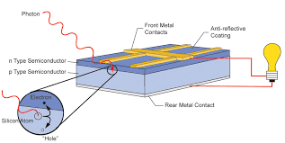
Figure 2.1 Generation of emf across junction to move the charge carriers.
- Free electrons cross the junction between two dissimilar crystals more easily in one direction than in the other, giving one side of the junction a negative charge, and this results in a negative voltage with respect to the other side, as in the case of a battery in which one electrode has negative voltage with respect to the other.
- The photovoltaic effect can continue to provide voltage and current as long as light falls on the junction of two materials.
2.2) BASIC PRINCIPAL OF SPV CONVERSION:
- Solar power is the production of electricity directly from sunlight. The solar photovoltaic (PV) power is produced using photovoltaic effect so that when sunlight strikes a solar voltaic cell, it releases electrons from the p-n junction of the cell and pushes these electrons across a potential barrier or electric field at the junction.
- These electrons then travel through an external circuit to return to their usual state and in this process create electric power.
- The photovoltaic effect is the basic physical process through which a PV or solar cell converts sunlight into electricity. Sunlight is composed of energy packets called photons.
- These photons contain different amounts of energy that correspond to different wavelengths of the solar spectrum. When photons strike a PV cell, they may be reflected, absorbed or can pass through the p-n junction. The absorbed photons in the p-n junction generate electricity.
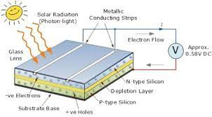
Figure 2.2 Photon generating pairs of electron and hole to move electric current in the external circuit.
- A solar cell is essentially a p-n junction with a large surface area. The n-type material is kept thin to allow light to pass through it and strike the p-n junction. The light travels in packets of energy called photons. The generation of electric current takes place inside the depletion zone of the p-n junction.
- The depletion zone as explained previously is the area around the p-n junction where ROHINI College of Engineering and Technology EE 8703 Renewable Energy System the electrons from the n-region diffuse into the holes of the p-region. When a photon of light is absorbed by one of these atoms in n-region of silicon, it will dislodge an electron from any atom, thereby creating a free electron and hole pair.
- The free electron and hole pair has sufficient energy to jump out of the depletion zone. If a wire is connected from the cathode at n-type silicon to an anode of p- type silicon, electrons flow through the wire.
- The electron is attracted to the positive charge of p-type material and travels through the external load (bulb or resistance), thereby creating a flow of electric current. The hole created by the dislodged electron is attracted to the negative charge of the n-type material and travels to back electrical contact. As the electron reaches the p-type silicon from the back electrical contact, it combines with the hole, thereby restoring the electrical neutrality(Figure 2.2)

TYPES OF SOLAR PV SYSTEMS
1.)PV Direct System
These are the simple most of solar PV systems, with the fewest components : the Solar Panels and the load. Because they don’t have batteries and are not hooked up to the grid, they only power the loads when the sun is shining. They are appropriate for a few applications e.g. water pumping or attic ventilation fan.
2.)Off-Grid System
Also referred to as stand-alone systems, it is designed to be independent of the power grid. Batteries are used to store energy when the sun is not an available during cloudy days or at night. This type of system will require regular attention to battery electrolyte levels and terminal corrosion.
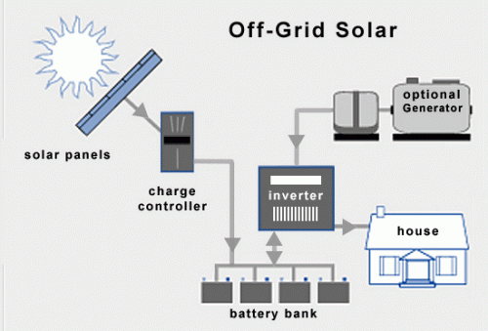
Figure 3.1 Off- Grid Solar
Features of Off-Grid Solar
- Independence from the utility grid
- Not subject to the terms/policies of the utility company
- Rate increases, blackouts, or brownouts do not apply
- In remote areas, it is cost effective than extending a grid
- Encourages energy efficiency
- Batteries require maintenance and has limited life
- More components means more complexity
- Batteries decrease system efficiency
- It is more expensive than a grid-direct system
- When the batteries are fully charged, potential power from the PV array is not utilized
- If the PV system fails, back-up electricity is required to run load
- Most off-grid systems use a backup generator for non-sunny days. They are expensive, noisy, dirty, and require fuel and regular maintenance
3.)Grid Tied System
These are most common type of PV systems. They are also known as on-grid, grid-tied, grid-intertied, or grid-direct systems. They generate solar electricity and route it to the loads and to the grid, offsetting some of electricity usage. System components comprised of the PV array and inverter. Grid-connected system is similar to regular electric powered system except that some or all of the electricity comes from the sun. The drawback of these battery less systems is that they provide no outage protection—when the utility grid fails, these systems cannot operate.)

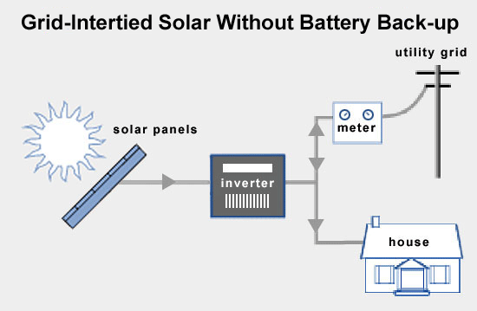
Figure 3.2 Grid -tied Solar without Battery Backup
Features of Grid -tied Solar System
- Increased design flexibility because the system does not have to power all of the home’s loads
- It is less expensive compared to stand-alone or grid-tied with battery backup systems
- It requires the least amount of maintenance
- If the system produces more than the loads need, then the extra energy is exchanged with the utility grid
- Grid-direct systems have a higher efficiency because batteries are not part of the system
- Higher voltage means smaller wire size
- Electricity costs are fixed for the life of your system
- There is no power to the home when the grid goes down
- Paperwork requirements for interconnection, incentives, and rebates
4.)Grid-tied with battery-backup system
This type is very similar to an off-grid system in design and components, but adds the utility grid, which reduces the need for the system to provide all the energy all the time.
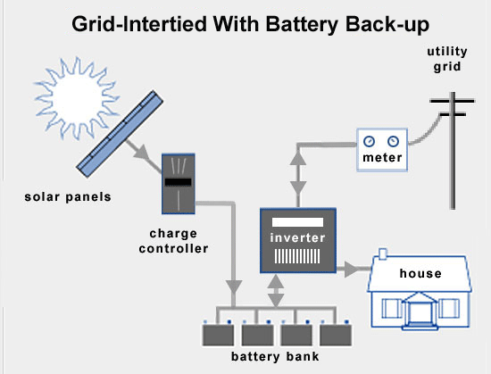
Figure 3.3 Grid -tied Solar with Battery Backup
Features of Grid -tied Solar System with Battery Backup
- Designated loads have power when the grid goes down
- If the system produces more than the home needs, then the extra energy is sold back to the utility- not lost as in a stand-alone systems after the batteries get full on a sunny day
- Batteries require maintenance
- Requires rewiring circuits from main service panel to a separate subpanel
- More components mean more complexity
- Batteries decrease system performance because of their efficiency losses
- More expensive than a grid-direct system
- Typically only provides modest backup – usually not all of the loads are backed up
- Requires paperwork for interconnection, incentives, and rebates
5.)Hybrid System
Hybrid system tries to combine multiple sources of power to maximize availability of power. It may source energy from sun, wind or diesel generator and back it up with battery.
Features of Hybrid System
- Multiple sources of generation allows for complementary sources and backup. For instance, when it is sunny out the PV array will charge the battery; if it is cloudy and windy, a wind turbine can charge the batteries
- Array size and battery bank capacity can typically be reduced and not having to oversize for periods of no sun
- More complex system design and installation
- Multiple power sources can increase upfront expenses
- Wind turbines and generators require regular maintenance

